

American International University-Bangladesh (AIUB)  
**Department of Computer Science  
Faculty of Science & Technology (FST)**

**ON DEMAND SECURITY SYSTEM**

A Software Engineering Project Submitted

By

|  |  |  |  |  |
| --- | --- | --- | --- | --- |
| **Semester: Summer_21_22** | | **Section:** | **Group Number:** | |
| SN | Student Name | Student ID | Contribution (CO1+CO2) | Individual Marks |
| 1 | MD. JAHID HASSAN | 19-40264-1 |  |  |
| 2 | MD. AHSANUL MOSTAKIN | 19-41342-3 |  |  |
| 3 | MD. MOHTASIN FUAD | 20-44021-2 |  |  |
| 4 | SAJJAD HOSSAIN SHAKIB | 20-43842-2 |  |  |
| 5 | TM RAGIB SHAHRIER | 19-39713-1 |  |  |

The project will be Evaluated for the following Course Outcomes

|  |  |  |
| --- | --- | --- |
| CO1: *Analyze* the impact of software engineering models over various context of software development to assess societal, health, safety, legal and cultural issues. | Total Marks | |
|  | |
| Project Background Analysis and feasibility (needs, goal, benefits, etc.) | [5 Marks] |  |
| Analysis the impact of societal, health, safety, legal and cultural issues | [5Marks] |  |
| Review of existing Studies and Relevant Example | [5Marks] |  |
| CO2: *Explain* appropriate software engineering model, project management roles and their skills in the context of professional engineering practice and solutions to complex engineering problems in a software development environment. | Total Marks | |
|  | |
| Appropriate Process Model Selection and Argumentation with Evidence | [5Marks] |  |
| Evidence of Argumentation regarding process model selection | [5Marks] |  |
| Submission, Defense, Completeness, Spelling, grammar and Organization of the Project report | [5Marks] |  |

Description of Student’s Contribution in the Project work

|  |
| --- |
| Student Name: MD. JAHID HASSAN  Student ID: 19-40264-1  Contribution in Percentage (20%):  Contribution in the Project:   * Create the project view * And discuss about What is the root cause of this problem? * Our proposed solution to the problem?   _________Jahid__________  Signature of the Student |
| Student Name: MD. AHSANUL MOSTAKIN  Student ID: 19-41342-3  Contribution in Percentage (20%):  Contribution in the Project:   * Think the necessary step of the project * And discuss about the why is this problem is so important to consider?   _______ Mostakin ______  Signature of the Student |
| Student Name: MD. MOHTASIN FUAD  Student ID: 20-44021-2  Contribution in Percentage (20%):  Contribution in the Project:   * Project proposal idea * And discuss about What is our project objective? * What are the basic functionalities of your proposed solution?   ________Fuad___________  Signature of the Student |
| Student Name: SAJJAD HOSSAIN SHAKIB  Student ID: 20-43842-2  Contribution in Percentage (20%):  Contribution in the Project:   * Working mechanism * And discuss about What solution are you going to provide to solve the above-mentioned problem.   _________Shakib__________  Signature of the Student |
| Student Name: TM RAGIB SHAHRIER  Student ID: 19-39713-1  Contribution in Percentage (20%):  Contribution in the Project:   * Think the real life perspective of project * And discuss about Who are the target group of users of your solution?   __________Ragib_________  Signature of the Student |

# PROJECT PROPOSAL

# ON DEMAND SECURITY SYSTEM

## Background to the Problem

* In our daily life sometimes, we need to go outside at late night for emergency work or when we visit any new place for working purpose or visiting, we feel the need of a guide who can help us to know the place or give us security. A female student or worker also wants security when they need to travel at night. Now-a-days it becomes so hard for working parents to take care of their children specially on the daytime. During Covid-19 pandemic we feel the need of delivery small things like official paper, home-made food to relative’s house and so many things. By giving security guard who will ensure safety, baby-sitter for alone children or a delivery man who will deliver small domestic products from one place to another can solve those mentioned problem. To keep it those necessity in our mind we want develop this project that will provide all those services whenever customers request it for.
* This project will create the opportunity for both customer and employee. The students those need part time job, jobless who need job, female students, all of them can earn money by giving those services to customer. And the general people who are the main customer will get service like security, baby care at daytime just by sending request using this system. Overall, it will create job sector for jobless and service sector for general people.

## Solution to the Problem

* Our Project is concern about to help common people with security especially women and children security. According to report it says daily 13 Females are being raped. The unregistered number is far more. The female Harassment in public places even outside of the school college are very alarming. Eve teasing rate is also high in our country. Our software and the ecosystem will solve this problem. The need for baby siting is increasing rapidly. As women are now working alongside man, they need a person to watch their babies. So, a platform of babysitters will help to fulfil the requirement of them.
* Women are half of our population. We cannot neglect them to devolvement of our nation. They are more vulnerable than man. If, women are harassed this way they will lose confident to do work and achieve something. As result families will discourage for women education and work. As result we will lose a capable force from our country. For our system women will feel safe to travel at night be themselves everywhere. As result the economy of our country will increase.
* We want to create a system which will provide on demand security services. Under this system there will be enough employees in both gender who will be ready for giving services whenever customers will request.
* As employees, there will work students, recently graduates who are searching for job and any candidate who can full-fill the job requirements. So, this system will target our job market by giving jobless’ work opportunity.
* The main audience would be general people. They will be able to request for services like security, baby-sitting, delivery home made products through this system whenever they are on need.

**1.Log in page**

* The software shall allow users to login with their given username and password.
* The login credentials (username and password) will be verified with database records.
* If the login successful, the home page of the user account will be displayed.
* If the username and/or password has been inserted wrong, the random verification code will be generated and sent to the user’s email address by the system to retry login.
* If the number of login attempt exceed its limit (3 times), the system shall block the user account login for one hour.
* Forgot password.
* Create account.

**2. Registration page:** There users need to give some information about him/her.

* Username.
* Email address.
* Age.
* Gender.
* Add photo.
* NID number.
* Contact number.
* Address.
* Password.
* Confirm password.
* Submit.

**3. Verification page:** To help your account safe developer wants to know it you-

* By a verification code in email.
* By a verification code in contact number.
* Get notify with a code.
* Verify with the code number.

**4. Home page:** In the main page of the software, we get some service topics-

* Home.
* Security Service.
* Guard security.
* Baby-sitting.
* Home delivery some expensive things.
* Employee.
* Contact.
* Hotline.
* Information.

**5. Job page for Employee:** Here employees know about their job information-

* Job Description
* Job details
* About job.
* About job requirements.
* About salaries and facilities.
* Apply for the job.

**6. Employee information:**

* Apply for job position.
* Name.
* Email address.
* Phone number.
* Age.
* Gender.
* Permanent address.
* Select City.
* Profile Picture.
* Input CV file.
* Enter father’s name.
* Enter mother’s name.
* Enter parents contact.
* Submit information.

**7. Payment**

* Bank payment
* Dhaka Bank
* UCB Bank
* Islamic Bank
* Card payment
* Dhaka Bank
* UCB Bank
* Islamic Bank
* Online Payment

* Bkash
* Nagad
* Rocket

**7. Log out:**

* Enter Username
* Password
* Registration

**USE CASE DIAGRAM**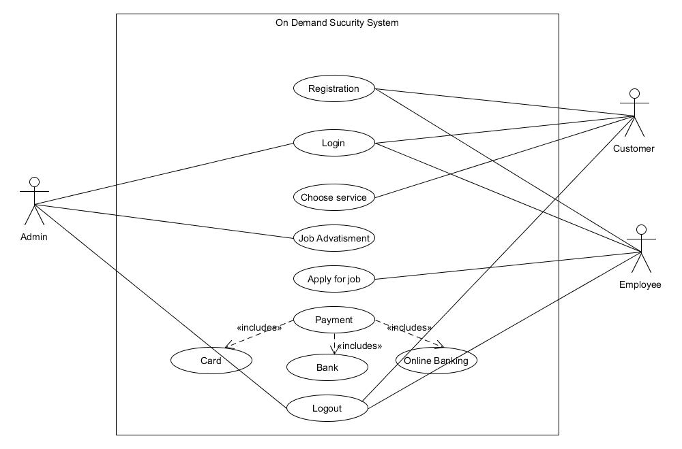

**ClASS DIAGRAM**

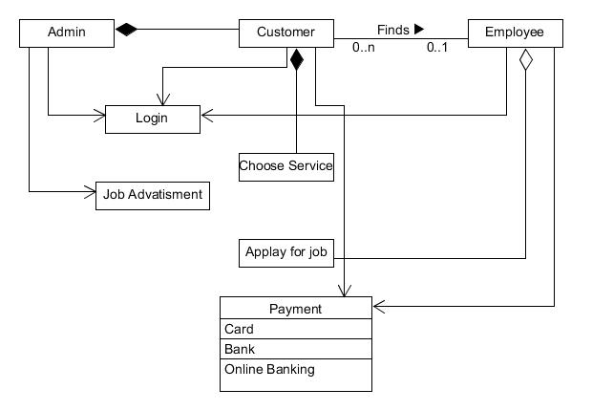

**ACTIVITY DIAGRAM**

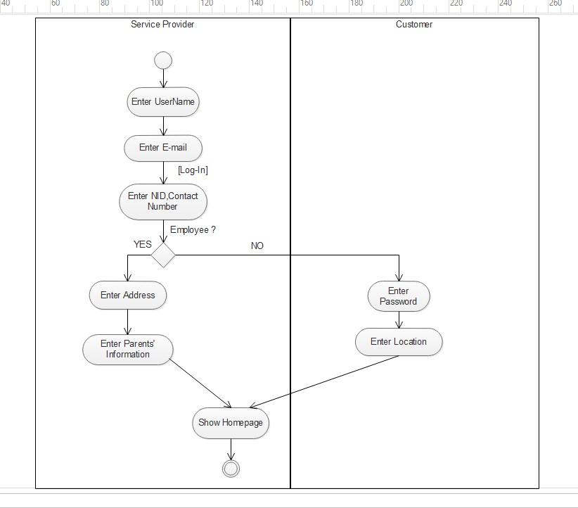

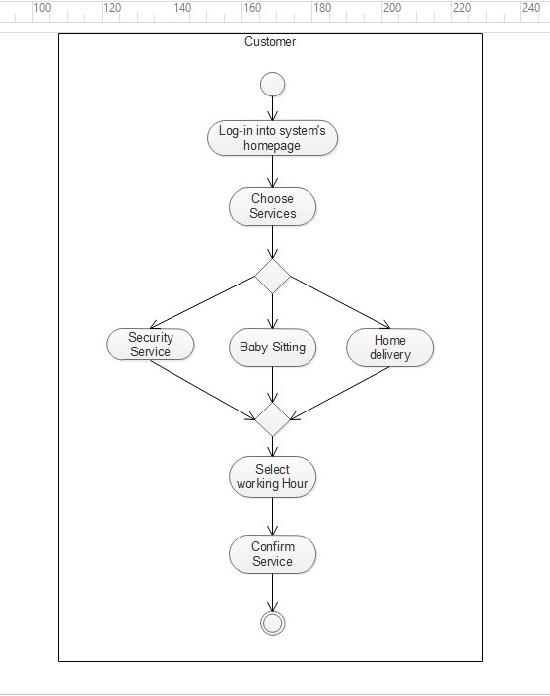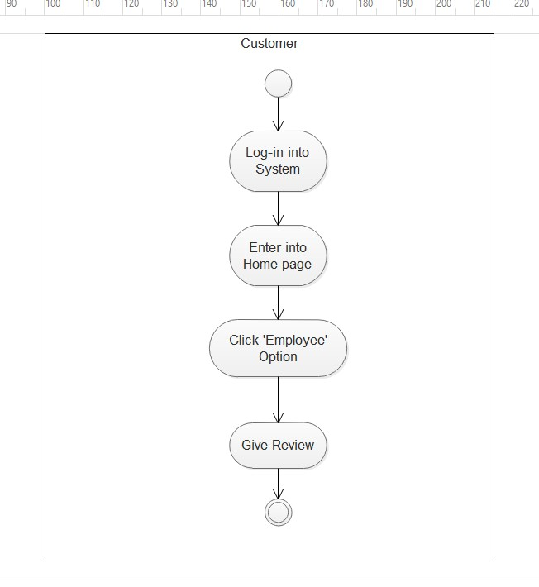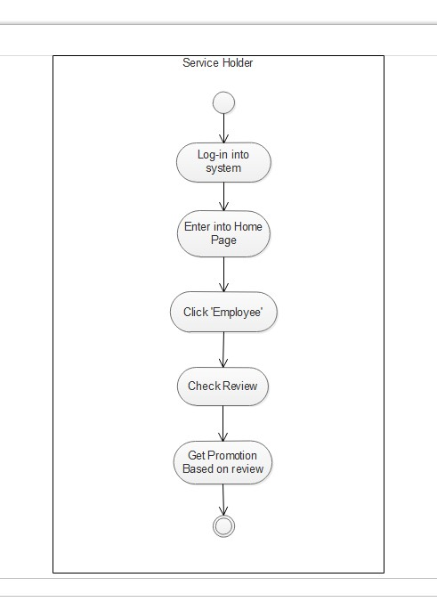

**SECUENCE DIAGRAM**

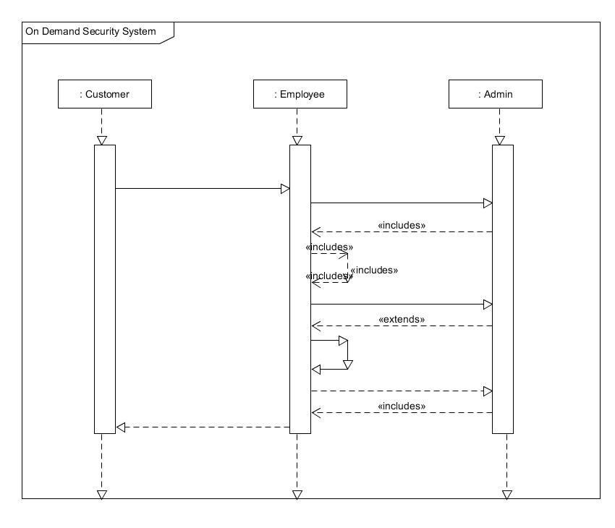

**STATE DIAGRAM**

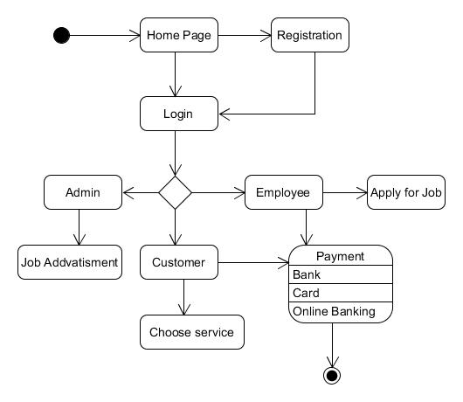

EXERCISE -2: Selection of Process Model.

**Objective:** The appropriate process model for the software development is SCRUM.

**Tools:** Ontology Development tool to check rational and consistency of our process model is SCRUM.

**Procedure:**

**1.Study the Software Engineering process model to appropriate process model to develop your proposed system solution.**

**Answer:** By Study the software Engineering process model to appropriate process model is SCRUM to develop our proposed system solution.

**2.** **Present your arguments based on your analysis about why your selected method(s) is the best choice among all other methods to develop your proposed software.**

**Answer:** Presenting our arguments based on our analysis about SCRUM why we selected method is the best choice among all other methods to develop our proposed software.

(i) Helps save time and money

With a traditional method and a responsible team, we can achieve wonders through SCRUM. The ability to manage tasks in an organized way and have the planning necessary to reach them makes it a crucial tool to save time and money. 15-minute daily meetings ensure that the process is at the correct stage, as established at the beginning of the project.

(ii) Encourages teamwork

With the division and assignment of roles and tasks efficiently, this methodology helps us work successfully on a project. The “product owner” and the “team” are complemented by the SCRUM Master, a resource that helps and supports the mission. The possibility of appreciating the work’s progress offers a guarantee that the process will be transparent and established.

(iii) It adapts to the company

The SCRUM methodology also provides the possibility of adjusting to the companies that use it. In this way, the idea of an organized production of tasks is conceived and a plan that goes hand in hand with the company in charge of the project and its characteristics.

(iv) It is easy to use

Through a methodology like SCRUM, the integration of all the parties involved in a project is successfully achieved. The participation and management of SCRUM are simple and easy to handle for all stages. Similarly, it has a record of work done and is monitored to achieve it efficiently.

**3**.**Identify all the roles in the project management activities in software development. Describes the responsibilities of the role in the software development.**

**Answer:** We have chosen the SCRUM model for our software development. Scrum defines some key roles for a scrum team. Depending on the situation, there are various mappings for a client and software product manager to these roles. In a large organization or a large product, the client, software product manager, product owner, and scrum master can be all different people. In a small start-up company, there may be significant overlap.

* **Product owner** is the one person who is responsible for the product. All product requirements for the developers must come through this role. The list of requirements for the product is gathered in a product backlog, which the product owner is responsible for. The product owner also determines the priorities of these requirements and ensures the requirements are clearly defined.

Naturally, the client could be the product owner, who determines the requirements and accepts the completed work. However, with clients inexperienced with defining clear requirements for developers, a software product manager may represent the client and take on the product owner role instead. If there is not an actual client, as in a mass-market product, then the software product manager may represent the end users and serve in the product owner role.

* **Scrum master** makes sure the scrum team adheres to scrum practices, by assisting the product owner and the development team. For the product owner, this help includes suggesting techniques to manage the product backlog, to attain clear requirements, and to prioritize for maximum value. For the development team members, this help includes coaching the team to self-organize and remove roadblocks. The scrum master also facilitates the four events listed above within a sprint. A team lead could be the scrum master to facilitate scrum practices by the team. In a small company, a software product manager with leadership qualities may need to take on the scrum master role. In any case of involvement, it is important for software product managers to understand the scrum roles and their responsibilities.
* **Scrum Development Team** are the developers on a scrum team, also known as the scrum development team, must be self-organizing. No one outside the development team, not even the scrum master or product owner, tells them how to turn the backlog of requirements for a sprint into developer tasks to produce an increment of working software. Scrum development teams are small, ideally between three and nine people. They are self-contained, consisting of everyone and everything needed to complete the product. Also, each member generally takes on mixed tasks, like doing both coding and testing, rather than having dedicated coders and testers. There are no special sub-teams. Everyone on the team is responsible for the team’s work products. Accountability rests with the entire team.

**4. Your Design Specification must address the evaluation rubrics mentioned in the software engineering course outline.**

**Answer:** This document describes the rubric we’ll use when grading our scrum model report. The points given reflect the importance of each element of our report. Many elements will span multiple sections of our report (e.g., you should be justifying your design throughout the report, not just in the evaluation section). The items in the rubric are not independent. A design that we cannot understand will result in a low score in more than one area.

**Overall System Design:**

Is your system design reasonable?

• Report describes all components of design

• Design meets the functionality requirements

• Design meets the constraints of the system

• Design addresses the additional requirement, either by solving it or explaining where our system breaks down

• Report addresses the security thought-experiment

• Design addresses all of the issues specified in the report assignment

**Design Justification and Evaluation:**

Have you convinced us that your design is reasonable?

• Report is explicit about design choices and justifies them throughout the report

• Calculates metrics detailed in the report assignment

• Includes any additional metrics appropriate for our system

• Gives context for numeric values, including how various design decisions affect the user

experience

**Overall Presentation:**

Is the report easy to follow, well-structured, etc.?

• Report is organized according to the defined structure (intro, design, analysis, etc.)

• Explanations are clear and concise

• Use of figures where appropriate; figures clarify the text rather than add confusion

**User Interface and Experience (UI/UX):**

**Login & Registration:**

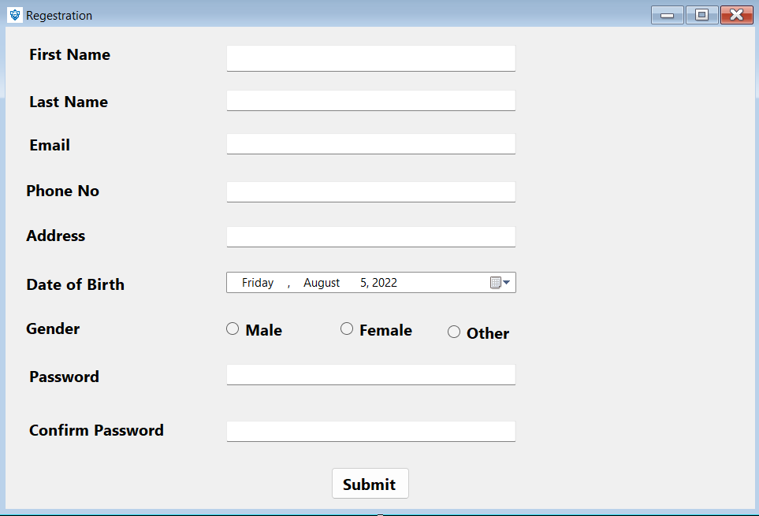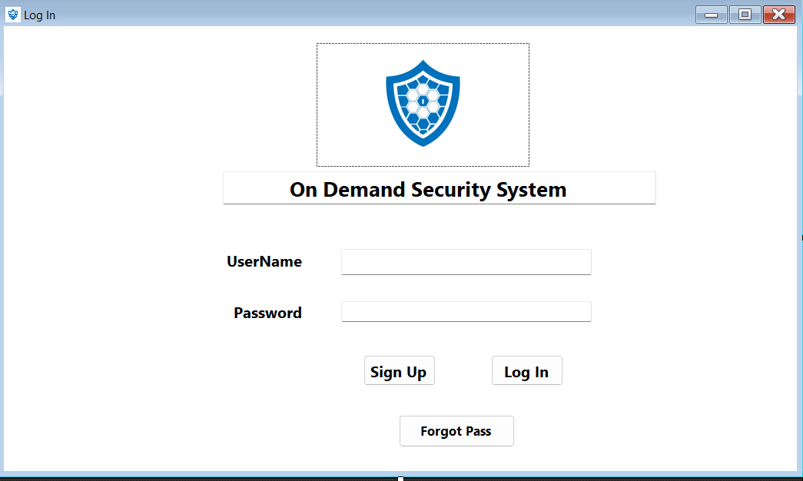

**Verification:**

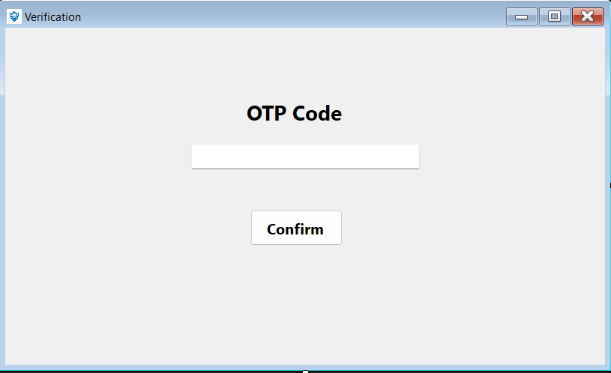

**Signup:**

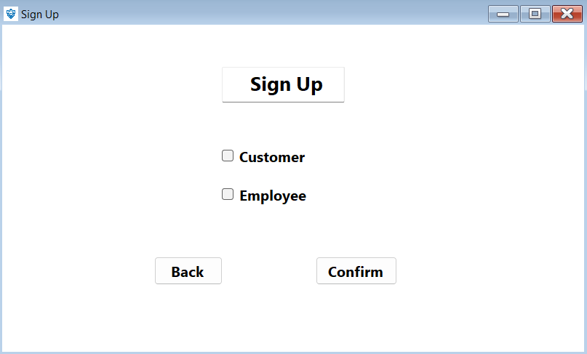**Home page:**

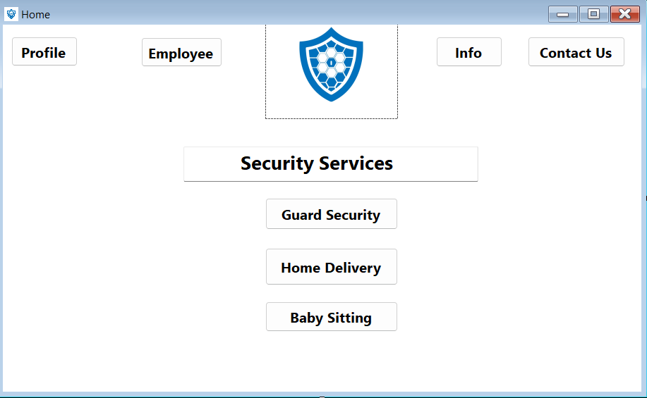

**Profile:**

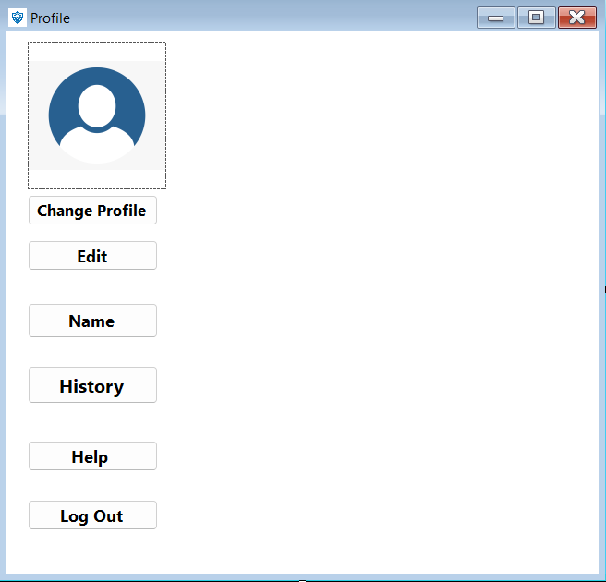

**Employee:**

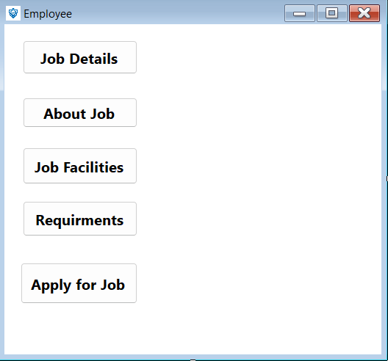

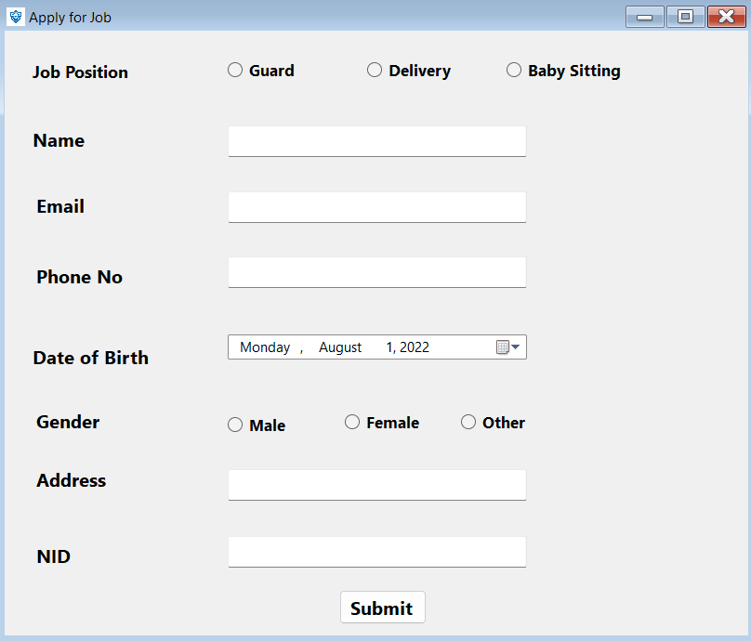**Apply for job:**

**Payment:**

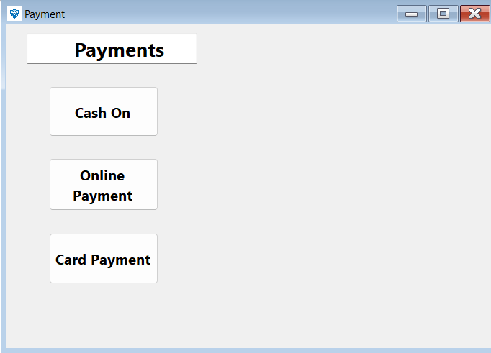

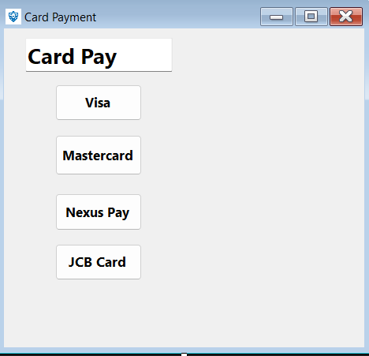

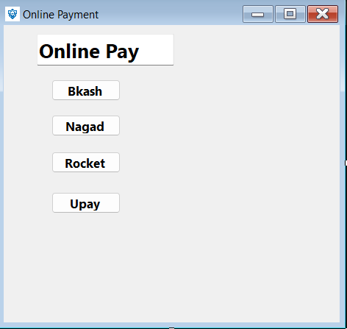

**Test Automation:**

|  |  |  |  |  |  |
| --- | --- | --- | --- | --- | --- |
| **Project Name:** One demand security System | | | **Test Design By:**  TM Ragib Shahrier | | |
| **Test Case ID:** FR_1 | | | Test Design Date: 19-07-2022 | | |
| **Test Priority:** Medium | | | **Text Executed By:**  TM Ragib Shahrier | | |
| **Module Name:** Login system | | | **Text Executed Date**: 19-07-2022 | | |
| **Test Title:** Verify login with valid username and password. | | | | | |
| **Description:** Test website login page. | | | | | |
| **Precondition:** User must have valid username and password. | | | | | |
| **Test Step** | **Test Data** | **Expected Result** | | **Actual**  **Result** | **Status** |
| 1.Go to the website.  2.Enter username.  3.Enter password.  4.Click submit. | Username: Ragib  Password: 123 | User should login into the application. | | As expected  Not expected | Pass  Fail |

|  |  |  |  |  |  |
| --- | --- | --- | --- | --- | --- |
| **Project Name:** On demand security system.  **Test case Id:** FR_2 | | | **Test Design by:**  Jahid Hassan  **Test Design date:**  26 July, 2022 | | |
| **Test Priority (Low, Medium, High):** Medium | | | **Test Executed by:**  Jahid Hassan | | |
| **Model Name:** Registration Session  **Test Title:** Verify registration with email or phone number code, giving the valid username, password and the other information.  **Description:** Test website registration page | | | **Test Execution Date:**  26 July, 2022 | | |
| **Precondition:** User must have NID, Phone number and valid address | | | | | |
| **Test Steps** | **Test Data** | **Expected Result** | | **Actual Result** | **Status** |
| 1. Go to the website 2. Enter all data 3. Enter new password 4. Enter confirm password 5. Click submit | NID no:  Phone no:  Confirm-password | User should valid NID, Phone no and password | | As expected  Not expected | Pass  Fail |
| **Post Condition:** User is valid with database and successfully registration. The account is created. | | | | | |

|  |  |  |  |  |  |
| --- | --- | --- | --- | --- | --- |
| **Project Name:** One demand security System | | | **Test Design By:**  TM Ragib Shahrier | | |
| **Test Case ID:** FR_3 | | | **Test Design Date:** 19-07-2022 | | |
| **Test Priority:** High | | | **Text Executed By:** TM Ragib Shahrier | | |
| **Module Name:** Verification page section. | | | **Text Executed Date:** 19-07-2022 | | |
| **Test Title:** Recover password with valid mail address. | | | | | |
| **Description:** Test website forgot page. | | | | | |
| **Precondition:** User must have valid account or create new account. | | | | | |
| **Test Step** | **Test Data** | **Expected Result** | | **Actual**  **Result** | **Status** |
| 1.Go to the website.  2.Enter valid mail address.  3.Check mail for verification code.  4.Enter verification code.  5.Click Submit | Mail address:  [ragib@gmail.com](mailto:ragib@gmail.com)  Verification code:  2314 | User should change the password. | | As expected  Not Expected | Pass  Fail |

|  |  |  |  |  |  |
| --- | --- | --- | --- | --- | --- |
| **Project Name:** On Demand Security System  **Test Case ID:** FR_4 | | | **Test Designed by:**  Sajjad Hossain Shakib  **Test Design date:**  July 26, 2022 | | |
| **Test Priority (Low, Medium, High):** Medium | | | **Test Executed by:**  Sajjad Hossain Shakib | | |
| **Module Name:** Home Page  **Test Title:** Users successfully login | | | **Test Execution Date:**  July 26, 2022 | | |
| **Description:** Test website home page. | | | | | |
| **Precondition:** Users must have login. | | | | | |
| **Test Steps** | **Test Data** | **Expected**  **Result** | | **Actual**  **Result** | **Status** |
| 1. Go to website 2. Log in |  | User should log in the application | | As expected, | Pass |

|  |  |  |  |  |  |
| --- | --- | --- | --- | --- | --- |
| **Project Name:** On Demand Security System  **Test Case ID:** FR_5 | | | **Test Designed by:**  Sajjad Hossain Shakib  **Test Design date:**  July 26, 2022 | | |
| **Test Priority (Low, Medium, High):** Medium | | | **Test Executed by:**  Sajjad Hossain Shakib | | |
| **Module Name:** Job page for Employee  **Test Title:** Users enter the job apply | | | **Test Execution Date:**  July 26, 2022 | | |
| **Description:** Test website job employee page. | | | | | |
| **Precondition:** Users must have entered the job apply page. | | | | | |
| **Test Steps** | **Test Data** | **Expected**  **Result** | | **Actual**  **Result** | **Status** |
| 1. Go to website 2. Log in 3. Enter the job Page | NID, phone number, email | User should have valid NID, phone no, email | | As expected, | Pass |

|  |  |  |  |  |  |
| --- | --- | --- | --- | --- | --- |
| **Project Name:** On Demand Security System  **Test Case ID:** FR_6 | | | **Test Designed by:**  Sajjad Hossain Shakib  **Test Design date:**  July 26, 2022 | | |
| **Test Priority (Low, Medium, High):** Medium | | | **Test Executed by:**  Sajjad Hossain Shakib | | |
| **Module Name:** Employees Information.  **Test Title:** Users successfully login. | | | **Test Execution Date:**  July 26, 2022 | | |
| **Description:** Test employee information page. | | | | | |
| **Precondition:** Users must have login and entered the home page. | | | | | |
| **Test Steps** | **Test Data** | **Expected**  **Result** | | **Actual**  **Result** | **Status** |
| 1. Go to website 2. Log in | ID, phone number, email, address. | User should log in the application | | As expected, | Pass |

|  |  |  |  |  |  |
| --- | --- | --- | --- | --- | --- |
| **Project Name:** On demand security system.  **Test case Id:** FR_7 | | | **Test Design by:**  Jahid Hassan  **Test Design date:**  26 July, 2022 | | |
| **Test Priority (Low, Medium, High):** High | | | **Test Executed by:**  Jahid Hassan | | |
| **Model Name:** Payment Session  **Test Title:** Verify account no and password  **Description:** Test website payment page | | | **Test Execution Date:**  26 July, 2022 | | |
| **Precondition:** User must have an account in this website, give the account information in website and must be an employee through on this website. | | | | | |
| **Test Steps** | **Test Data** | **Expected Result** | | **Actual Result** | **Status** |
| 1. Go to the website 2. Select payment 3. Choose Account type 4. Enter account no 5. Enter password 6. Click submit | Account no:  755843734523  Password:  8675 | User should minimum balance for withdraw | | As expected  Not expected | Pass  Fail |
| **Post Condition:** User is valid with database and successfully valid account. | | | | | |

|  |  |  |  |  |  |
| --- | --- | --- | --- | --- | --- |
| **Project Name:** On demand security system.  **Test case Id:** FR_8 | | | **Test Design by:**  Jahid Hassan  **Test Design date:**  26 July, 2022 | | |
| **Test Priority (Low, Medium, High):** Medium | | | **Test Executed by:**  Jahid Hassan | | |
| **Model Name:** Logout  **Test Title:** Account must be login  **Description:** Test website logout page | | | **Test Execution Date:**  26 July, 2022 | | |
| **Precondition:** User must have login first. | | | | | |
| **Test Steps** | **Test Data** | **Expected Result** | | **Actual Result** | **Status** |
| 1. Go to the website 2. Enter username 3. Enter password 4. Click logout 5. Click submit | Username  password | User should login website | | As expected  Not expected | Pass  Fail |
| **Post Condition:** User is valid with database and successfully login. | | | | | |

**Work Breakdown Structure**

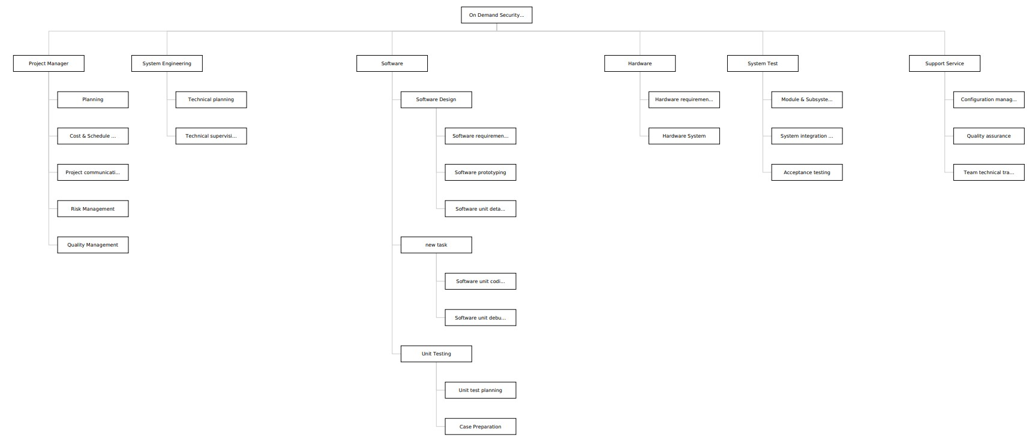

**Constructive Cost Model**

SLOC = 6000

P = 1.05 (simple project)

T = 0.38

Effort = PM = Coefficient<Effort Factor>*(SLOC/1000) ^P

= 2.4 * (6000/1000) ^1.05

= 15.75

= 16 months

Development time = DM = 2.50*(PM)^T

= 2.50 * (16) ^0.38

= 7.16 months

Required number of people = ST = PM/DM

= 16/7.16

= 2.24

= 3

|  |  |  |  |  |  |  |  |  |  |  |  |  |  |  |  |  |
| --- | --- | --- | --- | --- | --- | --- | --- | --- | --- | --- | --- | --- | --- | --- | --- | --- |
| **Weeks**  **Task: Person** | **Sprint 1** | | **Sprint 2** | | **Sprint 3** | | **Sprint 4** | | **Sprint 5** | | **Sprint 6** | | **Sprint 7** | | **Sprint 8** | |
| **1** | **2** | **3** | **4** | **5** | **6** | **7** | **8** | **9** | **10** | **11** | **12** | **13** | **14** | **15** | **16** |
| **A: Andy** |  |  |  |  |  |  |  |  |  |  |  |  |  |  |  |  |
| **B: Bill** |  |  |  |  |  |  |  |  |  |  |  |  |  |  |  |  |
| **C: Andy** |  |  |  |  |  |  |  |  |  |  |  |  |  |  |  |  |
| **D: Bill** |  |  |  |  |  |  |  |  |  |  |  |  |  |  |  |  |
| **E: Dave** |  |  |  |  |  |  |  |  |  |  |  |  |  |  |  |  |
| **F: Andy** |  |  |  |  |  |  |  |  |  |  |  |  |  |  |  |  |
| **G: Bill** |  |  |  |  |  |  |  |  |  |  |  |  |  |  |  |  |
| **H: Dave** |  |  |  |  |  |  |  |  |  |  |  |  |  |  |  |  |
| **I: Dave** |  |  |  |  |  |  |  |  |  |  |  |  |  |  |  |  |
| **J: Dave** |  |  |  |  |  |  |  |  |  |  |  |  |  |  |  |  |

**TIMELINE CHARTS:**



Activity Key: A: Overall design H: Code module 3

B: Specify module 1 I: Integration testing

C: Specify module 2 J: System testing

D: Specify module 3

E: Specify module 4

F: Code module 1

G: Code module 2

**TIMELINE CHARTS:**



|  |  |  |  |  |  |  |  |  |  |  |  |  |  |  |  |  |  |  |  |  |  |  |  |  |  |  |  |  |  |  |  |  |
| --- | --- | --- | --- | --- | --- | --- | --- | --- | --- | --- | --- | --- | --- | --- | --- | --- | --- | --- | --- | --- | --- | --- | --- | --- | --- | --- | --- | --- | --- | --- | --- | --- |
| **Weeks**  **Work tasks** | **1** | | | | **2** | | | | **3** | | | | **4** | | | | **5** | | | | | **6** | **7** | **8** | **9** | **10** | **11** | **12** | **13** | **14** | **15** | **16** |
| * 1. Identify needs and benefits   (Meet with customer)  (Identify needs and project constraints)  (Established project statement)  (Product statement defined)   * 1. Define desired output   (Scope keyboard functions)  (Scope voice input functions)  (Scope modes of interaction)  (Scope document diagnosis)  (Scope other WP functions)  (FIR: Review OCI with customer)  (Revise OCI as required)   * 1. Define the function   (Define keyboard functions)  (Define voice input functions)  (Describe modes of interaction)  (Describe other WP functions)  (FIR: Review OCI definition with customer) |  |  |  |  |  |  |  |  |  |  |  |  |  |  |  |  | |  |  |  |  |  |  |  |  |  |  |  |  |  |  |  | |  |  |

|  |  |  |  |  |  |  |  |  |  |  |  |  |  |  |  |  |  |  |  |  |  |  |  |  |  |  |  |  |  |  |  |  |  |  |  |  |  |  |  |  |  |  |
| --- | --- | --- | --- | --- | --- | --- | --- | --- | --- | --- | --- | --- | --- | --- | --- | --- | --- | --- | --- | --- | --- | --- | --- | --- | --- | --- | --- | --- | --- | --- | --- | --- | --- | --- | --- | --- | --- | --- | --- | --- | --- | --- |
| **Weeks**  **Work tasks** | **1-5** | **6** | | | | **7** | | | | **8** | | | | **9** | | | | **10** | | | | **11** | | | | **12** | | | | **13** | | | | **15** | | | **16** | | | | | |
| * 1. Isolation software elements   (Milestone: Software elements defined)   * 1. Research availability of existing software   (Research text editing components)  (Research voice input components)  (Research file management components)  (Research spell/grammar check components)  (Milestone: Software elements defined)   * 1. Define technical feasibility   (Evaluate voice input)  (Evaluate grammar checking)  (Milestone: Technical feasibility assessed)   * 1. Make quick estimate of size   2. Create a scope definition   (Review scope document with customer)  (Revise document as required)  (Milestone: Scope document complete) |  |  |  |  |  |  |  |  |  |  |  |  |  |  |  |  |  |  |  |  |  |  |  |  |  |  |  |  |  |  |  |  |  |  |  |  | |  |  |  |  |